**Survey of Masterson Station Park Equestrian Area Users**

Prepared by

Katherine Lampert  
Degree candidate for Agricultural Economics  
University of Kentucky

C. Jill Stowe, PhD  
Associate Professor of Agricultural Economics  
University of Kentucky

For

Masterson Equestrian Trust Foundation

17 April 2018

**Executive Summary**

*Objective*

A survey of equestrian facility users at Masterson Station Park was conducted to better understand the demographics of those who utilize the park, how often they come, and which parts of the park are used the most.

*Approach*

An online survey was distributed to Masterson Station Park equestrian facility users via Masteron Equestrian Trust’s Facebook page and MET’s email list.

*Overview of Results*

The equestrian facilities at Masterson Station Park primarily serves horse enthusiasts from Fayette County but also is frequented by equestrians from the broader central Kentucky and even from out-of-state. Visitors to the park are primarily female and span a broad age distribution. Equestrians visit to ride or drive at the park frequently and often come in groups. Nearly all of the available equestrian facilities are well-utilized.

*Overview*

Through its strategic planning process, the Masterson Equestrian Trust Foundation (MET) desired to better understand the impact of the equestrian facilities at Masterson Station Park (MSP). To this end, a survey tool was developed to be administered online using Survey Monkey. The survey tool consisted of 14 questions and was distributed through MET’s Facebook page and email list. The survey was open January 1, 2018, through February 15, 2018, and received 685 responses. The survey requested demographic information from the respondents, including location of residence, age, and gender. Other questions focused on their use of MSP, including frequency of visits and which parts of the park were used.

Included with this report in separate electronic files are an Excel file summarizing the responses from each question and a pdf of the survey tool.

*Results*

*Demographics – Residence of equestrian facility users*

Responses to Questions 1 and 2 illustrate that while MSP serves equestrians primarily in Fayette County, users come from many surrounding counties and even out of state. Graphs in tabs Question 1 and Question 2 show that 87% of the park’s equestrian users live in Kentucky. Among those:

* 36% are from Fayette County
* 12% are from Scott County
* 10% are from Woodford County
* 7% are from Jessamine County
* 6% are from Bourbon County
* 2% are from Madison County
* 1% are from Clark County

Among the respondents that do not live in Kentucky, the majority live in Ohio and Indiana, as seen in the figure below. States with zero responses are unlisted.

*Demographics – Gender and age of facility users*

Similar to the gender distribution in the non-racing segment of the equine industry, respondents were overwhelmingly female: over 96% of the respondents were female, with less than 4% of respondents being male (Question 12). The majority (26%) of respondents are between 25 and 34 years old (Question 13), and the total distribution of respondent age is as follows:

* Under 18 years old – 1.5%
* 18 – 24 years old – 10.6%
* 25 – 34 years old – 26.1%
* 35 – 44 years old – 19.5%
* 45 – 54 years old – 18.3%
* Age 55+: 24.0%

*Demographics – Primary discipline of facility users*

In Question 14, respondents were asked to select the primary discipline in which they participate. Among a list of 21 disciplines (including an “other” option), the top 5 primary disciplines represented by the respondents are:

* Eventing – 52.3%
* Pleasure/Trail Riding – 15. 0%
* Dressage – 8.7%
* Jumpers – 6.4%
* Fox Hunters – 6.2%

The entire list of responses can be viewed in the tab labeled “Question 14” in the Excel file.

*Frequency of visits to MSP*

Respondents to the survey are frequent users of the park. In 2017, 85% of the respondents visited the park more than once, and nearly 45% visited six or more times. In addition, it is uncommon for respondents to visit the park alone when they plan to ride or drive their horses. 81% of the respondents come in a group, with 15% typically riding or driving alone. 4% of the respondents did not visit MSP to ride or drive in 2017. More specifically, 69% of the respondents come with a small group of 1 to 3 people, while 26% of respondents come with a group of 4 to 6 people. The remaining 5% of the respondents that visit MSP to ride or drive came with a group of 7 or more people. These results can be found in the tabs labeled Question 4, Question 5, and Question 6 in the companion Excel file.

*Facilities typically utilized during visits to MSP*

Respondents were asked to identify all areas of the park that they typically use (see the tab labeled Question 7). It is apparent that respondents enjoy having access to many different facilities at the park. Respondents most often identified utilizing the beginner novice and novice cross county jumps. The figure below identifies the frequency with which respondents utilize different part of the park.

In addition, respondents were asked to identify all of the reasons why they visited the equestrian facilities at MSP in 2017. Choices included riding/driving related activities as well as “horseless” activities, such as supporting a friend or family member at a show to volunteering at an event. The top three reasons for visiting the park are to school the cross country jumps (72%), to ride or drive for pleasure (69%), and to participate in an equine event (68%). The complete set of responses is illustrated in the following table:

*Open-ended questions*

Finally, the respondents were asked three open-ended questions. Respondents were asked to describe what the equestrian area means to them in no more than three words. The top three words identified were “fun”, “riding”, and “schooling”. The numbers of responses associated with the ten most mentioned words can be found in the tab labeled Question 10 in the Excel file. The “word cloud” below identifies different words that respondents mentioned; the font size of words the words is related to the frequency with which they were mentioned (in other words, the most frequently mentioned words appear in the largest font, while less frequently mentioned words appear in smaller font).

**What does the equestrian area at Masterson Station Park mean to you?**

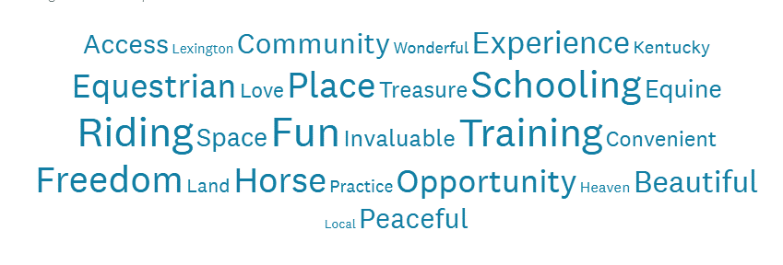

Respondents were also asked to describe what they liked about the equestrian area at Masterson Station Park. The top three things respondents liked about the park were that it is good for the horses and horse community, the availability of jumps, and easy and free accessibility. The numbers of responses associated with the ten most frequently mentioned words are in the tab labeled Question 9 of the Excel file. In addition, the responses were again organized in a word cloud, which is shared below.

**What do you like about the equestrian area at Masterson Station Park?**

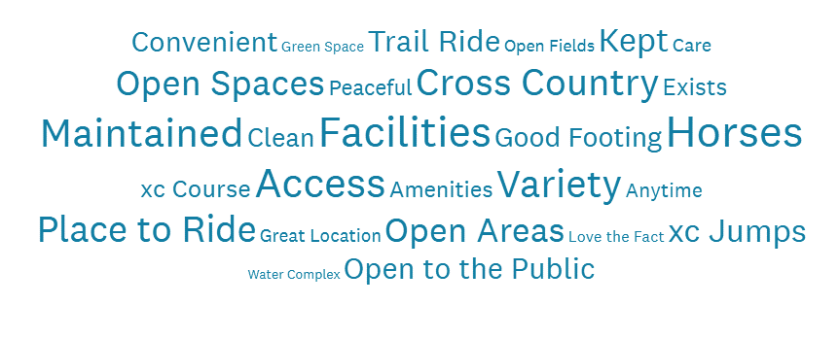

The other open-ended question allowed respondents to identify one thing they would choose to improve about the equestrian area at Masterson Station Park. The top three responses related to adding new jumps and maintaining the current jumps, more attention given to footing and groundhog holes, and more parking. The numbers of responses associated with the top ten mentioned words are in the tab labeled Question 11 of the companion Excel file. The responses organized into a word cloud is presented below.

**If you could improve one thing about the equestrian area at Masterson Station Park, what would it be?**



*Cross-tabulation of selected results*

After summarizing responses to each question, a more in-depth analysis was conducted on a selected set of questions. The first cross-tab examines the correlation between the respondent’s primary discipline and which parts of the park were utilized. Graphical results can be seen as a graph under the tab labeled *Discipline, Usage*. The second cross-tab examines the relationship between age and reason for visiting the park; the full results are available under the labeled tab *Age, Reason for Coming*. The final cross-tab examines the improvements respondents would like to see at the park by primary discipline. The compilation of these responses can be seen graphically under the tab *Improvements, Discipline*.

*Conclusion*

The equestrian area at Masterson Station Park presents a unique opportunity equestrian enthusiasts, primarily Fayette County but also those in Central Kentucky and even a few out of state, to have access to well-maintained spaces to ride and drive their horses and take part in equestrian events as spectators, volunteers, and managers. Different areas of the park are well-utilized, and those visiting on horseback enjoy the park many times a year. The results suggest that the equestrian area at MSP is not only a unique but also a vital part of the fabric of central Kentucky’s equestrian community.